**TRƯỜNG ĐẠI HỌC SÀI GÒN**

**KHOA CÔNG NGHỆ THÔNG TIN**

---------------🙢🕮🙠---------------

**ĐỒ ÁN MÔN HỌC XÂY DỰNG PHẦN MỀM**

**THEO MÔ HÌNH PHÂN LỚP**

**ĐỀ TÀI: QUẢN LÝ KHÓA HỌC**

**NHÓM**

**THÀNH VIÊN:**

3121410353 – Trần Khôi Nguyên

*Giảng viên:*

*Tp. Hồ chí minh, Ngày …. tháng …. năm ….*

**NHẬN XÉT CỦA GIẢNG VIÊN HƯỚNG DẪN**

**MỤC LỤC**

CHỨC NĂNG 1: QUẢN LÝ THÔNG TIN CÁC KHÓA HỌC ONLINE, ONSITE 3

1.1 Xử lý 1: hiển thị danh sách 3

1.2 Xử lý 2: hiển thị chi tiết 1 record (dòng) 3

1.3 Xử lý 3: thêm mới thông tin 3

1.4 Xử lý 4: sửa/ cập nhật thông tin 3

1.5 Xử lý 5: tìm kiếm 4

1.6 Xử lý 6: xóa record 4

CHỨC NĂNG 2: QUẢN LÝ THÔNG TIN PHÂN CÔNG GIẢNG DẠY (COURSEINTRUCTOR) 4

2.1 Xử lý 1: hiển thị danh sách 4

2.2 Xử lý 2: hiển thị chi tiết 1 record (dòng) 5

2.3 Xử lý 3: thêm mới thông tin 5

2.4 Xử lý 4: sửa/ cập nhật thông tin 5

2.5 Xử lý 5: tìm kiếm 6

2.6 Xử lý 6: xóa record 6

CHỨC NĂNG 3: QUẢN LÝ KẾT QUẢ KHÓA HỌC (STUDENTGRADE) 6

3.1 Xử lý 1: hiển thị danh sách 6

3.2 Xử lý 2: hiển thị chi tiết 1 record (dòng) 6

3.3 Xử lý 3: thêm mới thông tin 7

3.4 Xử lý 4: sửa/ cập nhật thông tin 7

3.5 Xử lý 5: tìm kiếm 7

3.6 Xử lý 6: xóa record 8

**Phân công việc làm và mức độ đóng góp:**

|  |  |  |  |
| --- | --- | --- | --- |
| **STT** | **Tên thành viên** | **Phần trăm tham gia hoàn thành đồ án (tổng 100%)** | **Công việc** |
| 1 | Trần Khôi Nguyên |  |  |
| 2 | Nguyễn Thanh Phong |  |  |
| 3 |  |  |  |
| 4 |  |  |  |
| 5 |  |  |  |
| 6 |  |  |  |

**CHỨC NĂNG 1: QUẢN LÝ THÔNG TIN CÁC KHÓA HỌC ONLINE, ONSITE**

## **1.1 Xử lý 1:** **hiển thị danh sách**

* **Sơ đồ tuần tự**

* **Màn hình giao diện**

* **Code 3 class: DAL, BLL, GUI**

## **1.2 Xử lý 2: hiển thị chi tiết 1 record (dòng)**

* **Sơ đồ tuần tự**

* **Màn hình giao diện**

* **Code 3 class: DAL, BLL, GUI**

## **1.3 Xử lý 3: thêm mới thông tin**

* **Sơ đồ tuần tự**

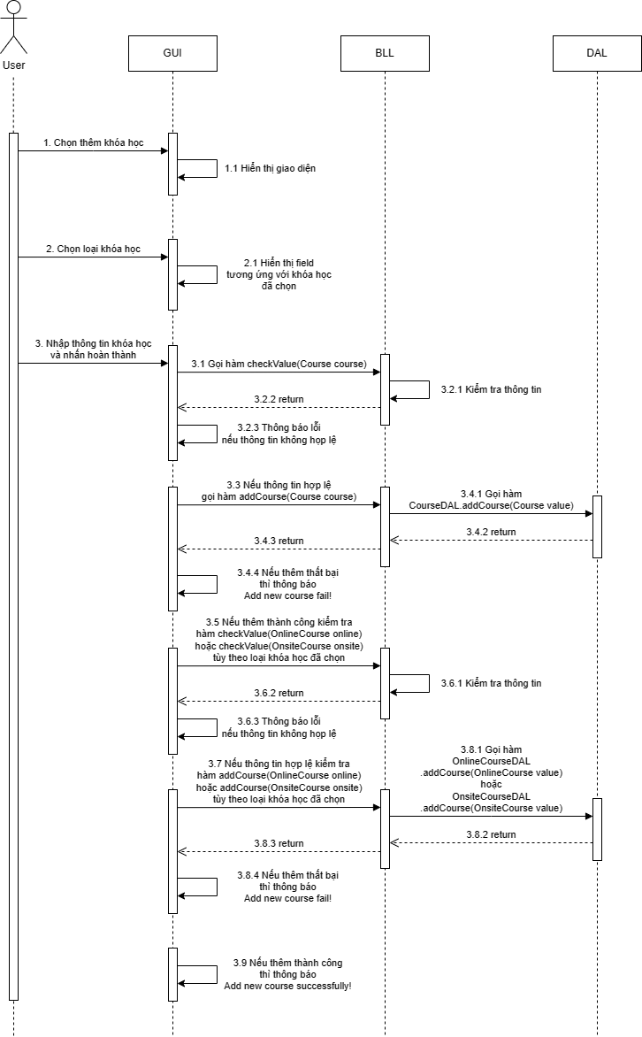

* **Màn hình giao diện**

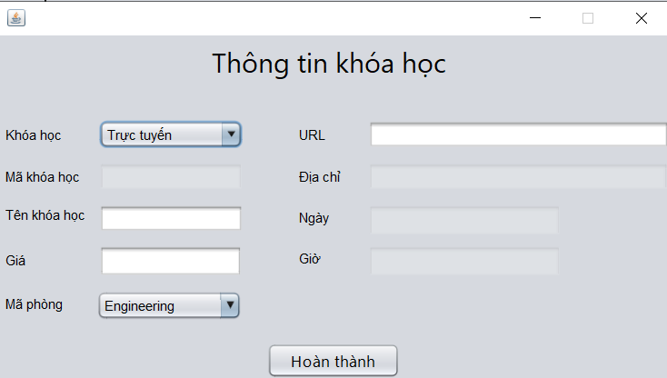

* **Code 3 class: DAL, BLL, GUI**

**CourseDAL**

**public** boolean addCourse(Course **value**) {

**try** {

String query = **"Insert into Course (Title, Credits, DepartmentID ) VALUES(?,?,?)"**;

PreparedStatement pst = c.prepareStatement(query);

pst.setNString(1, **value**.getTitle());

pst.setInt(2, **value**.getCredits());

pst.setInt(3, **value**.getDepartmentId());

**return** pst.executeUpdate() > 0;

} **catch** (SQLException ex) {

Logger.getLogger(CourseDAL.class.getName()).log(Level.SEVERE, **null**, ex);

}

**return** **false**;

}

**public** **int** getLastCourseId() throws SQLException {

String query = **"Select Max(CourseId) From Course"**;

PreparedStatement pst = c.prepareStatement(query);

ResultSet rs = pst.executeQuery();

**if** (rs.next()) {

**int** id = rs.getInt(1);

**return** id;

} **else** {

*// Xử lý trường hợp không có dữ liệu, ví dụ:*

**throw** **new** SQLException(**"No data found"**);

}

}

**OnlineCourseDAL**

**public** boolean addOnlineCourse(OnlineCourse **value**) {

**try** {

String query= **"Insert into onlinecourse (CourseID, url ) VALUES(?,?)"**;

PreparedStatement pst = c.prepareStatement(query);

pst.setInt(1, **value**.getCourseId());

pst.setNString(2, **value**.getUrl());

**return** pst.executeUpdate()> 0;

} **catch** (SQLException ex) {

Logger.getLogger(CourseDAL.class.getName()).log(Level.SEVERE, **null**, ex);

}

**return** **false**;

}

**OnsiteCourseDAL**

**public** boolean addOnsiteCourse(OnsiteCourse **value**) {

**try** {

String query= **"Insert into onsitecourse (CourseID, Location, Days, Time ) VALUES(?,?,?,?)"**;

PreparedStatement pst = c.prepareStatement(query);

pst.setInt(1, **value**.getCourseId());

pst.setNString(2, **value**.getLocation());

pst.setNString(3, **value**.getDays());

pst.setString(4, **value**.getTime());

**return** pst.executeUpdate() > 0;

} **catch** (SQLException ex) {

Logger.getLogger(CourseDAL.class.getName()).log(Level.SEVERE, **null**, ex);

}

**return** **false**;

}

**CourseBLL**

**public** **boolean** addCourse(Course course) {

**return** courseDAL.addCourse(course);

}

**public** **int** getLastCourseId() **throws** SQLException {

**return** courseDAL.getLastCourseId();

}

**public** String checkValue(Course course) {

**if**(**""**.equals(course.getTitle())) {

**return** **"Title not null!"**;

}

**else** **if**(course.getCredits() <= 0 || course.getCredits() > 4) {

**return** **"Credits must be numbers 1 through 4!"**;

}

**return** **"valid"**;

}

**OnlineCourseBLL**

**public** **boolean** addCourse(OnlineCourse online) {

**return** onlineCourseDAL.addOnlineCourse(online);

}

**public** String checkValue(OnlineCourse online) {

**if**(**""**.equals(online.getUrl())) {

**return** **"Url not null!"**;

}

**else** {

**try** {

**new** URL(online.getUrl());

} **catch** (MalformedURLException e) {

**return** **"Invalid url!"**;

}

}

**return** **"valid"**;

}

**OnsiteCourseBLL**

**public** boolean addCourse(OnsiteCourse onsite) {

**return** onsiteCourseDAL.addOnsiteCourse(onsite);

}

**public** String checkValue(OnsiteCourse onsite) {

**if**(**""**.equals(onsite.getLocation())) {

**return** **"location not null!"**;

}

**else** **if**(**""**.equals(onsite.getDays())) {

**return** **"days not null!"**;

}

**else** **if**(!onsite.getDays().matches(**"[MTWHFS]*"**)) {

**return** **"days must only contain M T W H F S"**;

}

**else** **if**(**""**.equals(onsite.getTime())) {

**return** **"time not null!"**;

}

**else** {

**try** {

DateTimeFormatter formatter = DateTimeFormatter.ofPattern(**"HH:mm:00"**);

LocalTime.parse(onsite.getTime(), formatter);

} **catch** (DateTimeParseException e) {

**return** **"Invalid time!"**;

}

}

**return** **"valid"**;

}

**CourseGUI**

*// TODO add your handling code here:*

CourseInsert_Edit courseInsert_Edit = **new** CourseInsert_Edit();

courseInsert_Edit.addWindowListener(**new** WindowAdapter() {

@Override

**public** **void** windowClosed(WindowEvent e) {

loadToTable(courseBLL.getList());

}

});

courseInsert_Edit.setDefaultCloseOperation(JFrame.DISPOSE_ON_CLOSE);

courseInsert_Edit.setInsert(**true**);

courseInsert_Edit.setFlag(**true**);

**try** {

courseInsert_Edit.getjComboBox1().setSelectedIndex(0);

courseInsert_Edit.getjComboBox1().setEnabled(**true**);

courseInsert_Edit.getjTextFieldId().setText(**""**);

courseInsert_Edit.getjTextFieldId().setEnabled(**false**);

courseInsert_Edit.getjTextFieldTen().setText(**""**);

courseInsert_Edit.getjTextFieldTen().setEditable(**true**);

courseInsert_Edit.getjTextFieldGia().setText(**""**);

courseInsert_Edit.getjTextFieldGia().setEditable(**true**);

courseInsert_Edit.getjTextFieldUrl().setText(**""**);

courseInsert_Edit.getjTextFieldUrl().setEditable(**true**);

courseInsert_Edit.getjTextFieldDiaChi().setEnabled(**false**);

courseInsert_Edit.getjTextFieldGio().setEnabled(**false**);

courseInsert_Edit.getjTextFieldNgay().setEnabled(**false**);

ArrayList<**String**> data = **new** ArrayList<>();

**for**(Department x: departmentBLL.getListDepartment()) {

data.add(x.getName());

}

courseInsert_Edit.getjComboBox2().setModel(**new** javax.swing.DefaultComboBoxModel<>(data.toArray(**String**[]::**new**)));

courseInsert_Edit.getjButton1().setVisible(**true**);

courseInsert_Edit.setVisible(**true**);

JOptionPane.showMessageDialog(**null**, **"Please enter all data!"**);

} **catch** (SQLException ex) {

Logger.getLogger(CourseGUI.class.getName()).log(Level.SEVERE, **null**, ex);

}

**CourseInsert_EditGUI**

Course course = new Course()*;*

course.setTitle(**jTextFieldTen.getText());** if(!**jTextFieldGia.getText().isEmpty())** {

course.setCredits(Integer.parseInt(**jTextFieldGia.getText()));** }

for(Department x: departmentBLL.getListDepartment()) {

if(x.getName().equals(**jComboBox2.getSelectedItem().toString()))** {

course.setDepartmentId(x.getDepartmentId())*;*

}

}

if(!**"valid"**.equals(courseBLL.checkValue(course))) {

**JOptionPane.showMessageDialog(this,** courseBLL.checkValue(course))*;*

}

else {

if(courseBLL.**addCourse(course))** {

if(**jComboBox1.getSelectedIndex()** == 0) {

OnlineCourse online = new OnlineCourse()*;*

online.setCourseId(courseBLL.getLastCourseId())*;*

online.setUrl(**jTextFieldUrl.getText());** if(!**"valid"**.equals(onlineBLL.checkValue(online))) {

**JOptionPane.showMessageDialog(this,** onlineBLL.checkValue(online))*;*

}

else {

if(onlineBLL.**addCourse(online))** {

**JOptionPane.showMessageDialog(this, "Add new course successfully!"**)*;*

Clear()*;*

}

else {

**JOptionPane.showMessageDialog(this, "Add new course fail!"**)*;*

}

}

}

else {

OnsiteCourse onsite = new OnsiteCourse()*;*

onsite.setCourseId(courseBLL.getLastCourseId())*;*

onsite.setLocation(**jTextFieldDiaChi.getText());** onsite.setDays(**jTextFieldNgay.getText());** onsite.setTime(**jTextFieldGio.getText());** if(!**"valid"**.equals(onsiteBLL.checkValue(onsite))) {

**JOptionPane.showMessageDialog(this,** onsiteBLL.checkValue(onsite))*;*

}

else {

if(onsiteBLL.**addCourse(onsite))** {

**JOptionPane.showMessageDialog(null, "Add new course successfully!"**)*;*

Clear()*;*

}

else {

**JOptionPane.showMessageDialog(this, "Add new course fail!"**)*;*

}

}

}

}

else {

**JOptionPane.showMessageDialog(this, "Add new course fail!"**)*;*

}

}

## **1.4 Xử lý 4: sửa/ cập nhật thông tin**

* **Sơ đồ tuần tự**

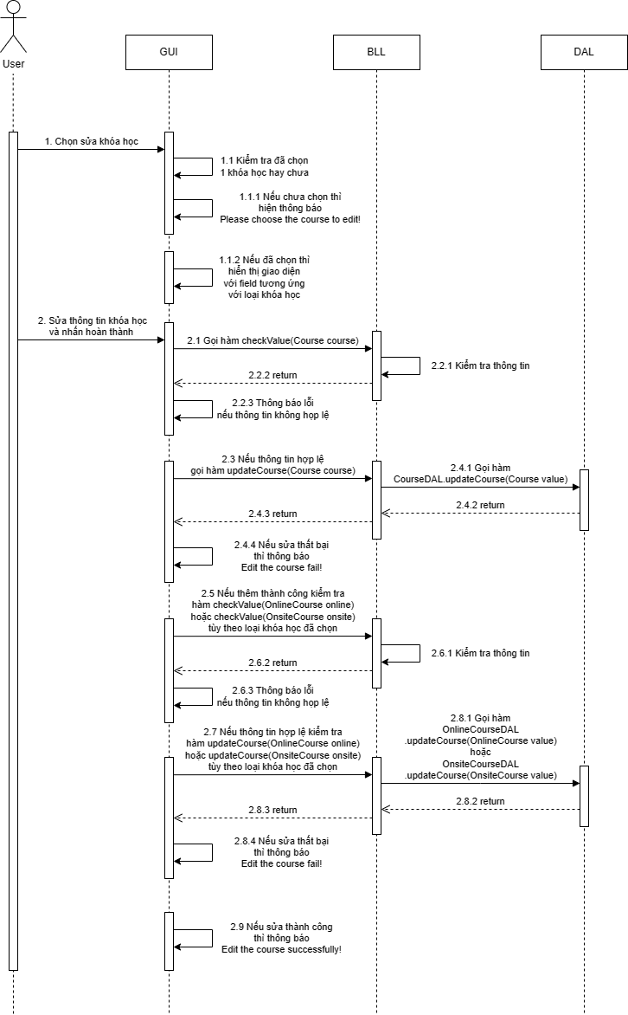

* **Màn hình giao diện**

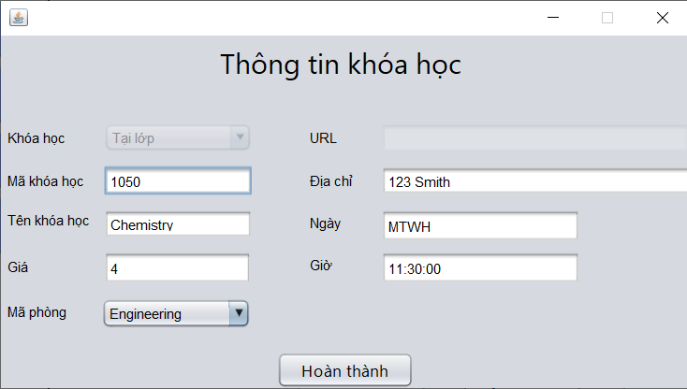

* **Code 3 class: DAL, BLL, GUI**

**CourseDAL**

**public** boolean updateCourse(Course **value**) {

**try** {

String query = **"update Course set Title=?, Credits=?, DepartmentID=? where CourseID=? "**;

PreparedStatement pst = c.prepareStatement(query);

pst.setNString(1, **value**.getTitle());

pst.setInt(2, **value**.getCredits());

pst.setInt(3, **value**.getDepartmentId());

pst.setInt(4, **value**.getCourseId());

**return** pst.executeUpdate() > 0;

} **catch** (SQLException ex) {

Logger.getLogger(CourseDAL.class.getName()).log(Level.SEVERE, **null**, ex);

}

**return** **false**;

}

**OnlineCourseDAL**

**public** boolean updateOnlineCourse(OnlineCourse **value**){

**try** {

String query= **"update onlinecourse set url=? where CourseID=? "**;

PreparedStatement pst= c.prepareStatement(query);

pst.setNString(1, **value**.getUrl());

pst.setInt(2, **value**.getCourseId());

**return** pst.executeUpdate() > 0;

} **catch** (SQLException ex) {

Logger.getLogger(CourseDAL.class.getName()).log(Level.SEVERE, **null**, ex);

}

**return** **false**;

}

**OnsiteCourseDAL**

**public** boolean updateOnsiteCourse(OnsiteCourse **value**){

**try** {

String query= **"update onsitecourse set Location=?, Days=?, Time=? where CourseID=? "**;

PreparedStatement pst= c.prepareStatement(query);

pst.setNString(1, **value**.getLocation());

pst.setNString(2, **value**.getDays());

pst.setString(3, **value**.getTime());

pst.setInt(4, **value**.getCourseId());

**return** pst.executeUpdate() > 0;

} **catch** (SQLException ex) {

Logger.getLogger(CourseDAL.class.getName()).log(Level.SEVERE, **null**, ex);

}

**return** **false**;

}

**CourseBLL**

**public** boolean updateCourse(Course course) {

**return** courseDAL.updateCourse(course);

}

**public** String checkValue(Course course) {

**if**(**""**.equals(course.getTitle())) {

**return** **"Title not null!"**;

}

**else** **if**(course.getCredits() <= 0 || course.getCredits() > 4) {

**return** **"Credits must be numbers 1 through 4!"**;

}

**return** **"valid"**;

}

**OnlineCourseBLL**

**public** **boolean** updateCourse(OnlineCourse online) {

**return** onlineCourseDAL.updateOnlineCourse(online);

}

**public** String checkValue(OnlineCourse online) {

**if**(**""**.equals(online.getUrl())) {

**return** **"Url not null!"**;

}

**else** {

**try** {

**new** URL(online.getUrl());

} **catch** (MalformedURLException e) {

**return** **"Invalid url!"**;

}

}

**return** **"valid"**;

}

**OnsiteCourseBLL**

**public** boolean updateCourse(OnsiteCourse onsite) {

**return** onsiteCourseDAL.updateOnsiteCourse(onsite);

}

**public** String checkValue(OnsiteCourse onsite) {

**if**(**""**.equals(onsite.getLocation())) {

**return** **"location not null!"**;

}

**else** **if**(**""**.equals(onsite.getDays())) {

**return** **"days not null!"**;

}

**else** **if**(!onsite.getDays().matches(**"[MTWHFS]*"**)) {

**return** **"days must only contain M T W H F S"**;

}

**else** **if**(**""**.equals(onsite.getTime())) {

**return** **"time not null!"**;

}

**else** {

**try** {

DateTimeFormatter formatter = DateTimeFormatter.ofPattern(**"HH:mm:00"**);

LocalTime.parse(onsite.getTime(), formatter);

} **catch** (DateTimeParseException e) {

**return** **"Invalid time!"**;

}

}

**return** **"valid"**;

}

**CourseGUI**

*// TODO add your handling code here:*

int selectedRow = jTable1.getSelectedRow();

CourseInsert_Edit courseInsert_Edit = **new** CourseInsert_Edit();

courseInsert_Edit.addWindowListener(**new** WindowAdapter() {

@Override

**public** **void** windowClosed(WindowEvent e) {

loadToTable(courseBLL.getList());

}

});

courseInsert_Edit.setDefaultCloseOperation(JFrame.DISPOSE_ON_CLOSE);

courseInsert_Edit.getjButton1().setVisible(**true**);

courseInsert_Edit.setInsert(**false**);

courseInsert_Edit.setFlag(**true**);

**if**(selectedRow != -1) {

*// Lấy dữ liệu từ hàng đã chọn*

boolean flag = **false**;

**for** (Course x : courseBLL.getList()) {

**if** (x.getCourseId() == (int) **this**.jTable1.getValueAt(selectedRow, 0)) {

**for** (OnlineCourse y : onlineCourseBLL.getList()) {

**if** (x.getCourseId() == y.getCourseId()) {

courseInsert_Edit.getjComboBox1().setSelectedIndex(0);

courseInsert_Edit.getjComboBox1().setEnabled(**false**);

courseInsert_Edit.getjTextFieldId().setText(Integer.toString(x.getCourseId()));

courseInsert_Edit.getjTextFieldId().setEditable(**false**);

courseInsert_Edit.getjTextFieldTen().setText(x.getTitle());

courseInsert_Edit.getjTextFieldTen().setEditable(**true**);

courseInsert_Edit.getjTextFieldGia().setText(Integer.toString(x.getCredits()));

courseInsert_Edit.getjTextFieldGia().setEditable(**true**);

courseInsert_Edit.getjTextFieldUrl().setText(y.getUrl());

courseInsert_Edit.getjTextFieldUrl().setEditable(**true**);

courseInsert_Edit.getjTextFieldDiaChi().setEnabled(**false**);

courseInsert_Edit.getjTextFieldGio().setEnabled(**false**);

courseInsert_Edit.getjTextFieldNgay().setEnabled(**false**);

ArrayList<**String**> data = **new** ArrayList<>();

**try** {

**for**(Department z: departmentBLL.getListDepartment()) {

data.add(z.getName());

}

courseInsert_Edit.getjComboBox2().setModel(**new** javax.swing.DefaultComboBoxModel<>(data.toArray(**String**[]::**new**)));

**for**(int i=0;i< courseInsert_Edit.getjComboBox2().getItemCount();i++){

**String** item= (**String**) courseInsert_Edit.getjComboBox2().getItemAt(i);

**if**(item.equals(departmentBLL.getDeparment(x.getDepartmentId()).getName())){

courseInsert_Edit.getjComboBox2().setSelectedIndex(i);

courseInsert_Edit.getjComboBox2().setEnabled(**true**);

**break**;

}

}

} **catch** (SQLException ex) {

Logger.getLogger(CourseGUI.class.getName()).log(Level.SEVERE, **null**, ex);

}

courseInsert_Edit.setVisible(**true**);

JOptionPane.showMessageDialog(**null**, **"Please do not leave the data blank!"**);

flag = **true**;

**break**;

}

}

**if** (flag) {

**continue**;

}

**for** (OnsiteCourse y : onsiteCourseBLL.getList()) {

**if** (x.getCourseId() == y.getCourseId()) {

courseInsert_Edit.getjComboBox1().setSelectedIndex(1);

courseInsert_Edit.getjComboBox1().setEnabled(**false**);

courseInsert_Edit.getjTextFieldId().setText(Integer.toString(x.getCourseId()));

courseInsert_Edit.getjTextFieldId().setEditable(**false**);

courseInsert_Edit.getjTextFieldTen().setText(x.getTitle());

courseInsert_Edit.getjTextFieldTen().setEditable(**true**);

courseInsert_Edit.getjTextFieldGia().setText(Integer.toString(x.getCredits()));

courseInsert_Edit.getjTextFieldGia().setEditable(**true**);

courseInsert_Edit.getjTextFieldUrl().setEnabled(**false**);

courseInsert_Edit.getjTextFieldDiaChi().setText(y.getLocation());

courseInsert_Edit.getjTextFieldDiaChi().setEditable(**true**);

courseInsert_Edit.getjTextFieldGio().setText(y.getTime().toString());

courseInsert_Edit.getjTextFieldGio().setEditable(**true**);

courseInsert_Edit.getjTextFieldNgay().setText(y.getDays());

courseInsert_Edit.getjTextFieldNgay().setEditable(**true**);

ArrayList<**String**> data = **new** ArrayList<>();

**try** {

**for**(Department z: departmentBLL.getListDepartment()) {

data.add(z.getName());

}

courseInsert_Edit.getjComboBox2().setModel(**new** javax.swing.DefaultComboBoxModel<>(data.toArray(**String**[]::**new**)));

**for**(int i=0;i< courseInsert_Edit.getjComboBox2().getItemCount();i++){

**String** item= (**String**) courseInsert_Edit.getjComboBox2().getItemAt(i);

**if**(item.equals(departmentBLL.getDeparment(x.getDepartmentId()).getName())){

courseInsert_Edit.getjComboBox2().setSelectedIndex(i);

courseInsert_Edit.getjComboBox2().setEnabled(**true**);

**break**;

}

}

} **catch** (SQLException ex) {

Logger.getLogger(CourseGUI.class.getName()).log(Level.SEVERE, **null**, ex);

}

courseInsert_Edit.setVisible(**true**);

JOptionPane.showMessageDialog(**null**, **"Please do not leave the data blank!"**);

**break**;

}

}

}

}

*// Mở một hộp thoại chỉnh sửa hoặc một form chỉnh sửa với dữ liệu đã chọn*

*// Ví dụ: new EditDialog(data).setVisible(true);*

} **else** {

JOptionPane.showMessageDialog(**null**, **"Please choose the course to edit!"**);

}

**CourseInsert_EditGUI**

Course course = **new** Course();

course.setCourseId(Integer.parseInt(jTextFieldId.**getText**()));

course.setTitle(jTextFieldTen.**getText**());

**if**(!jTextFieldGia.**getText**().isEmpty()) {

course.setCredits(Integer.parseInt(jTextFieldGia.**getText**()));

}

**for**(Department x: departmentBLL.getListDepartment()) {

**if**(x.getName().equals(jComboBox2.getSelectedItem().toString())) {

course.setDepartmentId(x.getDepartmentId());

}

}

**if**(!**"valid"**.equals(courseBLL.checkValue(course))) {

JOptionPane.showMessageDialog(**this**, courseBLL.checkValue(course));

}

**else** {

**if**(courseBLL.updateCourse(course)) {

**if**(jComboBox1.getSelectedIndex() == 0) {

OnlineCourse online = **new** OnlineCourse();

online.setCourseId(Integer.parseInt(jTextFieldId.**getText**()));

online.setUrl(jTextFieldUrl.**getText**());

**if**(!**"valid"**.equals(onlineBLL.checkValue(online))) {

JOptionPane.showMessageDialog(**this**, onlineBLL.checkValue(online));

}

**else** {

**if**(onlineBLL.updateCourse(online)) {

JOptionPane.showMessageDialog(**null**, **"Edit the course successfully!"**);

Clear();

dispose();

}

**else** {

JOptionPane.showMessageDialog(**null**, **"Edit the course fail!"**);

}

}

}

**else** {

OnsiteCourse onsite = **new** OnsiteCourse();

onsite.setCourseId(Integer.parseInt(jTextFieldId.**getText**()));

onsite.setLocation(jTextFieldDiaChi.**getText**());

onsite.setDays(jTextFieldNgay.**getText**());

onsite.setTime(jTextFieldGio.**getText**());

**if**(!**"valid"**.equals(onsiteBLL.checkValue(onsite))) {

JOptionPane.showMessageDialog(**this**, onsiteBLL.checkValue(onsite));

}

**else** {

**if**(onsiteBLL.updateCourse(onsite)) {

JOptionPane.showMessageDialog(**null**, **"Edit the course successfully!"**);

Clear();

dispose();

}

**else** {

JOptionPane.showMessageDialog(**null**, **"Edit the course fail!"**);

}

}

}

}

**else** {

JOptionPane.showMessageDialog(**null**, **"Edit the course fail!"**);

}

}

## **1.5 Xử lý 5: tìm kiếm**

* **Sơ đồ tuần tự**

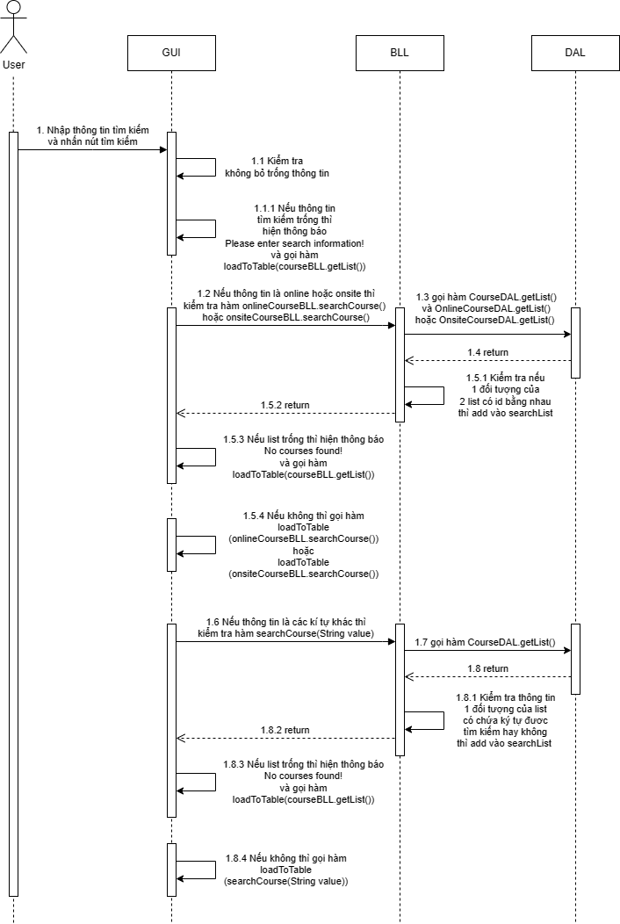

* **Màn hình giao diện**

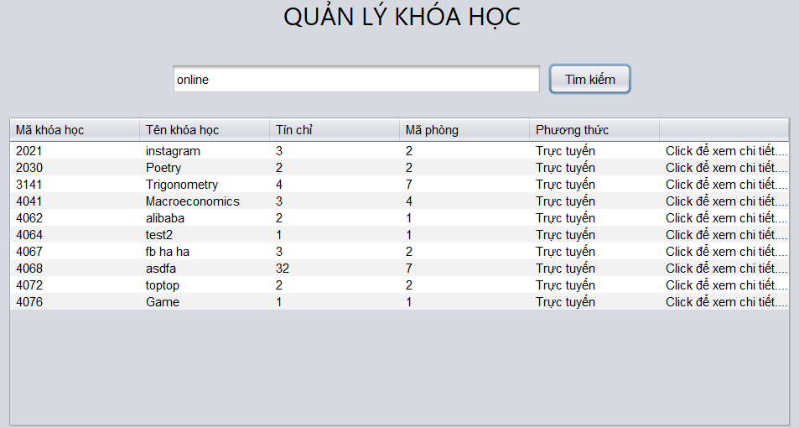

* **Code 3 class: DAL, BLL, GUI**

**CourseDAL**

**public** ArrayList<Course> getList() {

ArrayList list = **new** ArrayList<Course>();

String query = **"select *from Course"**;

**try** {

PreparedStatement pst = c.prepareStatement(query);

ResultSet rs = pst.executeQuery();

**while** (rs.next()) {

Course **value** = **new** Course();

**value**.setCourseId(rs.getInt(1));

**value**.setTitle(rs.getString(2));

**value**.setCredits(rs.getInt(3));

**value**.setDepartmentId(rs.getInt(4));

list.add(**value**);

}

} **catch** (SQLException ex) {

Logger.getLogger(CourseDAL.class.getName()).log(Level.SEVERE, **null**, ex);

}

**return** list;

}

**OnlineCourseDAL**

**public** ArrayList<OnlineCourse> getList() {

ArrayList list = **new** ArrayList<OnlineCourse>();

String query = **"select *from onlinecourse"**;

**try** {

PreparedStatement pst = c.prepareStatement(query);

ResultSet rs = pst.executeQuery();

**while** (rs.next()) {

OnlineCourse **value** = **new** OnlineCourse();

**value**.setCourseId(rs.getInt(1));

**value**.setUrl(rs.getString(2));

list.add(**value**);

}

} **catch** (SQLException ex) {

Logger.getLogger(CourseDAL.class.getName()).log(Level.SEVERE, **null**, ex);

}

**return** list;

}

**OnsiteCourseDAL**

**public** ArrayList<OnsiteCourse> getList() {

ArrayList list = **new** ArrayList<OnsiteCourse>();

String query = **"select *from onsitecourse"**;

**try** {

PreparedStatement pst = c.prepareStatement(query);

ResultSet rs = pst.executeQuery();

**while** (rs.next()) {

OnsiteCourse **value** = **new** OnsiteCourse();

**value**.setCourseId(rs.getInt(1));

**value**.setLocation(rs.getString(2));

**value**.setDays(rs.getString(3));

**value**.setTime(rs.getString(4));

list.add(**value**);

}

} **catch** (SQLException ex) {

Logger.getLogger(CourseDAL.class.getName()).log(Level.SEVERE, **null**, ex);

}

**return** list;

}

**CourseBLL**

**public** ArrayList<Course> searchCourse(String value) {

ArrayList<Course> list = **new** ArrayList<>();

**for** (Course x : **this**.getList()) {

String id = Integer.toString(x.getCourseId()).toLowerCase();

String credits = Integer.toString(x.getCredits()).toLowerCase();

String department = Integer.toString(x.getDepartmentId()).toLowerCase();

**if** (id.contains(value.toLowerCase()) || x.getTitle().toLowerCase().contains(value.toLowerCase()) || credits.contains(value.toLowerCase()) || department.contains(value.toLowerCase())) {

list.add(x);

}

}

**return** list;

}

**OnlineCourseBLL**

**public** ArrayList<Course> searchCourse(){

ArrayList<Course> searchList= **new** ArrayList<>();

**for** (Course x : courseDAL.getList()) {

**for**(OnlineCourse y : getList()) {

**if**(x.getCourseId() == y.getCourseId()){

searchList.add(x);

}

}

}

**return** searchList;

}

**OnsiteCourseBLL**

**public** ArrayList<Course> searchCourse(){

ArrayList<Course> searchList= **new** ArrayList<>();

**for** (Course x : courseDAL.getList()) {

**for**(OnsiteCourse y : getList()) {

**if**(x.getCourseId() == y.getCourseId()){

searchList.add(x);

}

}

}

**return** searchList;

}

**CourseGUI**

*// TODO add your handling code here:*

**if**(**""**.equals(jTextField1.getText())) {

JOptionPane.showMessageDialog(**null**, **"Please enter search information!"**);

loadToTable(courseBLL.getList());

}

**else** {

**if**(**"online"**.equalsIgnoreCase(jTextField1.getText())) {

**if**(onlineCourseBLL.searchCourse().isEmpty()) {

JOptionPane.showMessageDialog(**null**, **"No courses found!"**);

}

**else** {

loadToTable(onlineCourseBLL.searchCourse());

}

}

**else** **if**(**"onsite"**.equalsIgnoreCase(jTextField1.getText())) {

**if**(onsiteCourseBLL.searchCourse().isEmpty()) {

JOptionPane.showMessageDialog(**null**, **"No courses found!"**);

}

**else** {

loadToTable(onsiteCourseBLL.searchCourse());

}

}

**else** **if**(courseBLL.searchCourse(jTextField1.getText()).isEmpty()) {

JOptionPane.showMessageDialog(**null**, **"No courses found!"**);

loadToTable(courseBLL.getList());

}

**else** {

loadToTable(courseBLL.searchCourse(jTextField1.getText()));

}

}

## **1.6 Xử lý 6: xóa record**

* **Sơ đồ tuần tự**

* **Màn hình giao diện**

* **Code 3 class: DAL, BLL, GUI**

# **CHỨC NĂNG 2: QUẢN LÝ THÔNG TIN PHÂN CÔNG GIẢNG DẠY (COURSEINTRUCTOR)**

## **2.1 Xử lý 1: hiển thị danh sách**

* **Sơ đồ tuần tự**

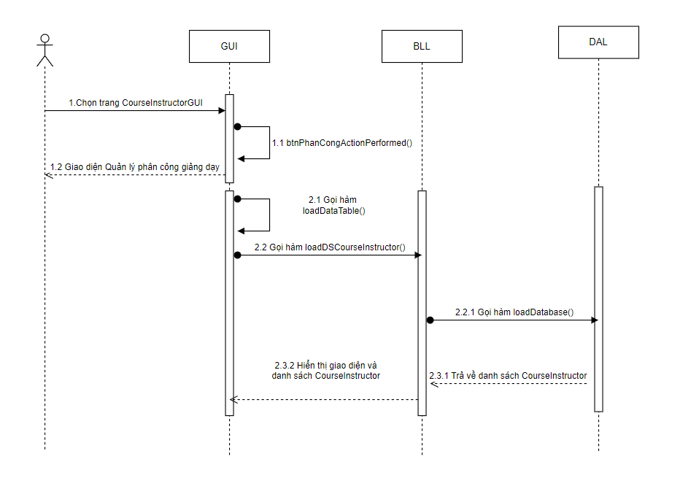

* **Màn hình giao diện**

* **Code 3 class: DAL, BLL, GUI**

**-CourseInstructorDAL**

**public** ArrayList<CourseInstructor> loadDatabase() throws Exception {

ArrayList<CourseInstructor> **list** = new ArrayList<>();

Statement **st** = c.createStatement();

String **query** ="SELECT CourseInstructor.CourseID, CourseInstructor.PersonID,"

+ " CONCAT(Person.LastName, ' ', Person.FirstName) AS Name,Course.Title "

+ " FROM Person "

+ "JOIN CourseInstructor ON Person.PersonID = CourseInstructor.PersonID"

+ " JOIN Course ON CourseInstructor.CourseID = Course.CourseID ";

try {

ResultSet rs = **st**.executeQuery(**query**);

**while** (rs.next()) {

CourseInstructor csin = new CourseInstructor(

rs.getInt("CourseID"),

rs.getString("Title"),

rs.getInt("PersonID"),

rs.getString("Name")

);

**list**.add(csin);

}

rs.**close**();

} catch (SQLException **ex**) {

System.**out**.println("Khong the load database CourseInstructor: " + **ex**);

}

**return** **list**;

}

**-CourseInstructorBLL**

**public** ArrayList<CourseInstructor> **loadDSCourseInstructor**() **throws** Exception{

**return** dal.loadDatabase();

}

**-CourseIntructorGUI**

**public** CourseIntructorGUI() throws Exception {

initComponents();

btnXong.setVisible(!true);

btnHuy.setVisible(!true);

loadDataTable(cIBLL.loadDSCourseInstructor());

comboBoxModel = loadDataCourseToCombobox( courseBLL.loadData());

nameCourse.setModel(comboBoxModel);

comboBoxModelPS = loadDataPersonToCombobox(personBLL.loadData());

namePerson.setModel(comboBoxModelPS);

nameCourse.setSelectedIndex(0);

namePerson.setSelectedIndex(0);

}

**public** void loadDataTable( ArrayList<CourseInstructor> data) throws Exception{

model.setRowCount(0);

model = addArrayListToTable(data);

tableCourseIns.setModel(model);

}

## **2.2 Xử lý 2: hiển thị chi tiết 1 record (dòng)**

* **Sơ đồ tuần tự**

* **Màn hình giao diện**

* **Code 3 class: DAL, BLL, GUI**

**- CourseInstructorDAL**

**public** ArrayList<CourseInstructor> loadDatabase() throws Exception {

ArrayList<CourseInstructor> **list** = new ArrayList<>();

Statement **st** = c.createStatement();

String **query** ="SELECT CourseInstructor.CourseID, CourseInstructor.PersonID,"

+ " CONCAT(Person.LastName, ' ', Person.FirstName) AS Name,Course.Title "

+ " FROM Person "

+ "JOIN CourseInstructor ON Person.PersonID = CourseInstructor.PersonID"

+ " JOIN Course ON CourseInstructor.CourseID = Course.CourseID ";

try {

ResultSet rs = **st**.executeQuery(**query**);

**while** (rs.next()) {

CourseInstructor csin = new CourseInstructor(

rs.getInt("CourseID"),

rs.getString("Title"),

rs.getInt("PersonID"),

rs.getString("Name")

);

**list**.add(csin);

}

rs.**close**();

} catch (SQLException **ex**) {

System.**out**.println("Khong the load database CourseInstructor: " + **ex**);

}

**return** **list**;

}

**-File CourseBLL**

**public** Course findElement(**int** id) throws **Exception**{

ArrayList<Course> **list** = courseDAL.loadDatabase();

**for**(Course co : **list**){

**if**(co.getCourseId() == id)

**return** co;

}

**return** **null**;

}

**-LecturesBLL**

**public** Lecturers findElement(**int** id) throws **Exception**{

ArrayList<Lecturers> **list** = dal.loadDatabase();

**for**(Lecturers ps : **list**){

**if**(ps.getPersonId() == id)

**return** ps;

}

**return** **null**;

}

**- CourseInstructorGUI**

**private** **void** **tableCourseInsMouseClicked**(java.awt.event.MouseEvent evt) {

// TODO add your handling code here:

**int** selectedRow = tableCourseIns.getSelectedRow();

nameCourse.setEnabled(false);

namePerson.setEnabled(false);

**int** courseID = Integer.parseInt(model.getValueAt(selectedRow, 0).toString());

**int** personID = Integer.parseInt(model.getValueAt(selectedRow, 2).toString());

**try** {

Course cour= (Course) courseBLL.findElement(courseID);

Lecturers lect = (Lecturers) personBLL.findElement(personID);

comboBoxModel.setSelectedItem(cour);

comboBoxModelPS.setSelectedItem(lect);

} **catch** (Exception ex) {

Logger.getLogger(CourseIntructorGUI.**class**.getName()).log(Level.SEVERE, null, ex);

}

}

## 

## **2.3 Xử lý 3: thêm mới thông tin**

* **Sơ đồ tuần tự**

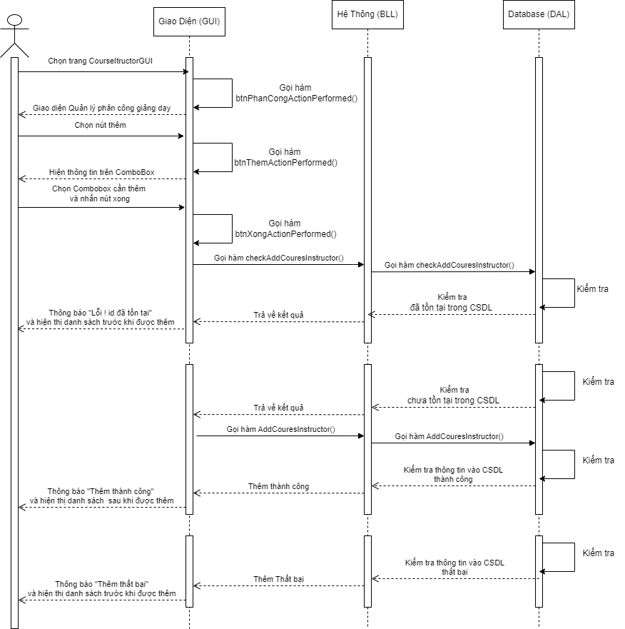

* **Màn hình giao diện**

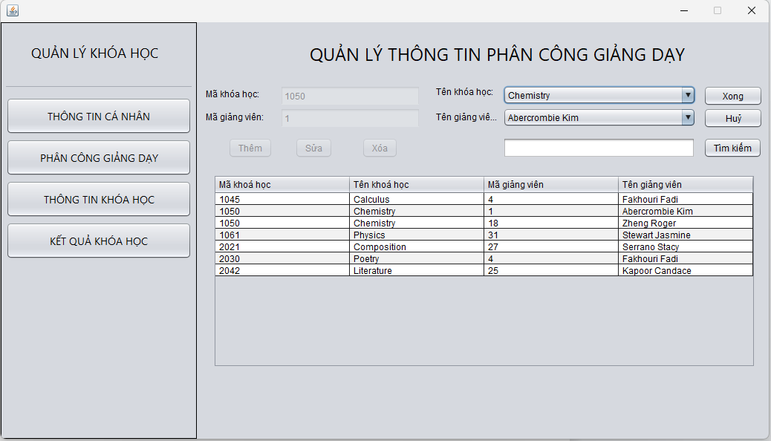

* **Code 3 class: DAL, BLL, GUI**

**DAL: CourseIntructorDAL.java**

public boolean addCourseInstructor(int CourseID, int PersonID) throws SQLException {

        String query = "INSERT INTO CourseInstructor (CourseID, PersonID) VALUES (?, ?)";

        try (PreparedStatement p = c.prepareStatement(query)) {

            p.setInt(1, CourseID);

            p.setInt(2, PersonID);

            int rowsAffected = p.executeUpdate();

            return rowsAffected > 0;

        }

}

public int checkAddCourseInstructor(int CourseID, int PersonID) throws SQLException {

        String query = "SELECT COUNT(*) FROM CourseInstructor WHERE CourseID = ? AND PersonID = ?";

        try (PreparedStatement p = c.prepareStatement(query)) {

            p.setInt(1, CourseID);

            p.setInt(2, PersonID);

            ResultSet rs = p.executeQuery();

            rs.next();

            int count =rs.getInt(1);

            return count ;

        }

  }

**BLL: CourseIntructorBLL.java**

public static boolean addCourseInstructor( int idcorse, int idperson) throws SQLException {

        return dal.addCourseInstructor(  idcorse, idperson);

}

public static int checkAddCourseInstructor( int idcourse, int idperson) throws SQLException {

        return dal.checkAddCourseInstructor( idcourse, idperson);

}

**GUI: CourseIntructorGUI.java**

btnThem.setText("Thêm");

btnThem.addActionListener(new java.awt.event.ActionListener() {

public void actionPerformed(java.awt.event.ActionEvent evt) {

btnThemActionPerformed(evt);

}

});

pprivate void btnThemActionPerformed(java.awt.event.ActionEvent evt) {

        int luaChon = JOptionPane.showConfirmDialog(null, "Có thêm không?", "Hỏi", JOptionPane.YES_NO_OPTION);

        if (luaChon == JOptionPane.YES_OPTION) {

            insert = true;

            nameCourse.setEnabled(true);

            namePerson.setEnabled(true);

            btnThem.setEnabled(false);

            btnSua.setEnabled(false);

            btnXoa.setEnabled(false);

            btnXong.setVisible(true);

            btnHuy.setVisible(true);

        }

}

private void btnXongActionPerformed(java.awt.event.ActionEvent evt)

{//GEN-FIRST:event_btnXongActionPerformed

        // TODO add your handling code here:

        if(!insert) {

            int maKhoahoc = Integer.parseInt(maKH.getText());

            int maGiangvien = Integer.parseInt(maGV.getText());

            try {

                CourseInstructor a =  cIBLL.returnOld();

                CourseInstructor b =  cIBLL.getCourseInstructorNewByID(courseBLL.findElement(maKhoahoc),personBLL.findElement(maGiangvien));

                if(!cIBLL.updateCourseInstructor(a, b)){

                    JOptionPane.showMessageDialog( null, "Update fail!!!?" );

                }else{

                  JOptionPane.showMessageDialog( null, "Update success!!!?" );

                }

                txtSearch.setText("");

                model.setRowCount(0);

                model = addArrayListToTable(cIBLL.loadDSCourseInstructor());

                tableCourseIns.setModel(model);

                btnHuyActionPerformed(evt);

            } catch (Exception ex) {

                Logger.getLogger(CourseIntructorGUI.class.getName()).log(Level.SEVERE, null, ex);

            }

        }

        else {

            int maKhoahoc = Integer.parseInt(maKH.getText());

            int maGiangvien = Integer.parseInt(maGV.getText());

            try {

                if (CourseInstructorBLL.checkAddCourseInstructor(maKhoahoc, maGiangvien) == 0) {

                    if(CourseInstructorBLL.addCourseInstructor(maKhoahoc, maGiangvien)) {

                        JOptionPane.showMessageDialog(null, "Thêm thành công!");

                    }

                    else {

                        JOptionPane.showMessageDialog(null, "Thêm thất bại!");

                    }

                } else {

                    JOptionPane.showMessageDialog(null, "Lỗi! id đã tồn tại");

                }

                // Cập nhật bảng hiển thị

                txtSearch.setText("");

                model.setRowCount(0);

                model = addArrayListToTable(cIBLL.loadDSCourseInstructor());

                tableCourseIns.setModel(model);

                nameCourse.setEnabled(false);

                namePerson.setEnabled(false);

                btnThem.setEnabled(!false);

                btnSua.setEnabled(!false);

                btnXoa.setEnabled(!false);

                btnXong.setVisible(!true);

                btnHuy.setVisible(!true);

            } catch (Exception e) {

                // Xử lý ngoại lệ nếu có

                e.printStackTrace();

                JOptionPane.showMessageDialog(null, "Đã xảy ra lỗi: " + e.getMessage(), "Lỗi", JOptionPane.ERROR_MESSAGE);

            }

        }

}

## **2.4 Xử lý 4: sửa/ cập nhật thông tin**

* **Sơ đồ tuần tự**

* **Màn hình giao diện**

* **Code 3 class: DAL, BLL, GUI**

**-CourseInstructorDAL**

**public** Boolean updateCourseInstructor(CourseInstructor csinOld, CourseInstructor csinNew) **throws** Exception {

String sql = "UPDATE CourseInstructor SET CourseID = ?, PersonID = ? WHERE CourseID = ? AND PersonID = ?";

**try** {

PreparedStatement preparedStatement = c.prepareStatement(sql);

preparedStatement.setString(1, Integer.toString(csinNew.getCourseID()));

preparedStatement.setString(2, Integer.toString(csinNew.getPersonID()));

preparedStatement.setString(3, Integer.toString(csinOld.getCourseID()));

preparedStatement.setString(4, Integer.toString(csinOld.getPersonID()));

preparedStatement.executeUpdate();

**return** true;

} **catch** (SQLException ex) {

System.out.println("Khong the Cap nhat CourseInstructor vao database !!!");

**return** false;

}

}

**-CourseInstructorBLL**

**public** boolean updateCourseInstructor(CourseInstructor csinOld, CourseInstructor csinNew) throws Exception{

**if**(csinOld.getCourseID()==csinNew.getCourseID() && csinOld.getPersonID()== csinNew.getPersonID())

**return** false;

**try** {

dal.updateCourseInstructor(csinOld,csinNew);

**return** true;

} **catch** (Exception e) {

System.**out**.println("Khong the Cap nhat CourseInstructor vao database !!!");

}

**return** false;

}

**-CourseInstructorGUI**

**private** **void** btnXongActionPerformed(java.awt.event.ActionEvent evt) {

// TODO add your handling code here:

**if**(!insert) {

**int** maKhoahoc = Integer.parseInt(maKH.**getText**());

**int** maGiangvien = Integer.parseInt(maGV.**getText**());

**try** {

CourseInstructor a = cIBLL.returnOld();

CourseInstructor b = cIBLL.getCourseInstructorNewByID(courseBLL.findElement(maKhoahoc),personBLL.findElement(maGiangvien));

**if**(!cIBLL.updateCourseInstructor(a, b)){

JOptionPane.showMessageDialog( **null**, "Update fail!!!?" );

}**else**{

JOptionPane.showMessageDialog( **null**, "Update success!!!?" );

}

txtSearch.setText("");

model.setRowCount(0);

model = addArrayListToTable(cIBLL.loadDSCourseInstructor());

tableCourseIns.setModel(model);

btnHuyActionPerformed(evt);

} **catch** (Exception ex) {

Logger.getLogger(CourseIntructorGUI.**class**.getName()).log(Level.SEVERE, **null**, ex);

}

}

**else** {

**int** maKhoahoc = Integer.parseInt(maKH.**getText**());

**int** maGiangvien = Integer.parseInt(maGV.**getText**());

**try** {

**if** (CourseInstructorBLL.checkAddCourseInstructor(maKhoahoc, maGiangvien) == 0) {

**if**(CourseInstructorBLL.addCourseInstructor(maKhoahoc, maGiangvien)) {

JOptionPane.showMessageDialog(**null**, "Thêm thành công!");

}

**else** {

JOptionPane.showMessageDialog(**null**, "Thêm thất bại!");

}

} **else** {

JOptionPane.showMessageDialog(**null**, "Lỗi! id đã tồn tại");

}

// Cập nhật bảng hiển thị

txtSearch.setText("");

model.setRowCount(0);

model = addArrayListToTable(cIBLL.loadDSCourseInstructor());

tableCourseIns.setModel(model);

nameCourse.setEnabled(**false**);

namePerson.setEnabled(**false**);

btnThem.setEnabled(!**false**);

btnSua.setEnabled(!**false**);

btnXoa.setEnabled(!**false**);

btnXong.setVisible(!**true**);

btnHuy.setVisible(!**true**);

} **catch** (Exception e) {

// Xử lý ngoại lệ nếu có

e.printStackTrace();

JOptionPane.showMessageDialog(**null**, "Đã xảy ra lỗi: " + e.getMessage(), "Lỗi", JOptionPane.ERROR_MESSAGE);

}

}

}

## **2.5 Xử lý 5: tìm kiếm**

* **Sơ đồ tuần tự**

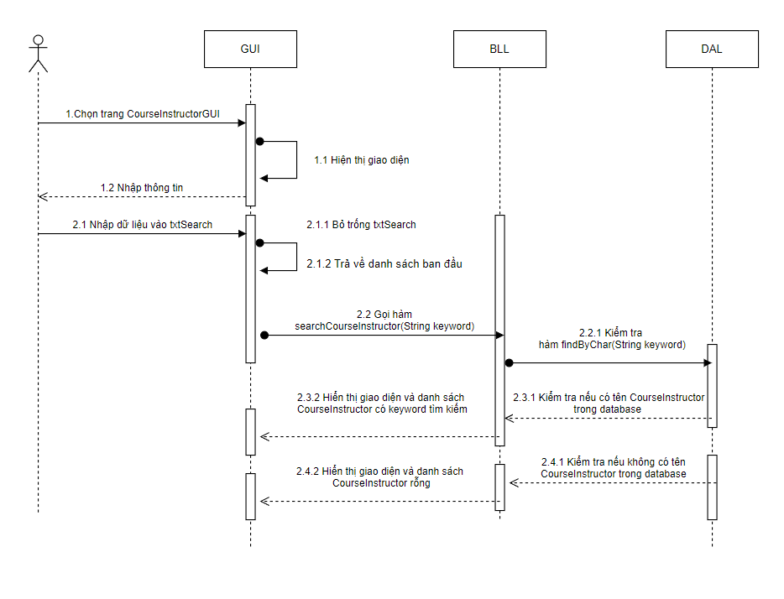

* **Màn hình giao diện**

* **Code 3 class: DAL, BLL, GUI**

**- CourseIntructorDAL**

**public** ArrayList<CourseInstructor> findByChar(String keyword){

ArrayList<CourseInstructor> list = new ArrayList<>();

String sql = "SELECT DISTINCT "

+ " CourseInstructor.CourseID, CourseInstructor.PersonID, "

+ " CONCAT(Person.LastName, ' ', Person.FirstName) AS Name,Course.Title "

+ " FROM Person "

+ " JOIN CourseInstructor ON Person.PersonID = CourseInstructor.PersonID "

+ " JOIN Course ON CourseInstructor.CourseID = Course.CourseID "

+ " WHERE CONCAT(Person.LastName, ' ', Person.FirstName) LIKE ? "

+ " OR Course.Title LIKE ?; ";

try{

PreparedStatement preparedStatement = c.prepareStatement(sql);

preparedStatement.setString(1, "%" + keyword + "%");

preparedStatement.setString(2, "%" + keyword + "%");

**ResultSet** rs = preparedStatement.executeQuery();

**while**(rs.next()){

CourseInstructor csin = new CourseInstructor(

rs.getInt("CourseID"),

rs.getString("Title"),

rs.getInt("PersonID"),

rs.getString("Name")

);

list.add(csin);

}

// c.close();

}

catch (SQLException ex) {

System.out.println("Khong the tim CourseInstructor !!!");

}

**return** list;

}

**-CourseInstructorBLL**

**public** ArrayList<CourseInstructor> searchCourseInstructor(String keyword)

{

**return** dal.findByChar(keyword);

}

**-** **CourseInstructorGUI**

**private** **void** txtSearchKeyReleased(java.awt.event.KeyEvent evt) {

// TODO add your handling code here:

**if**(txtSearch.**getText**().isEmpty()){

model.setRowCount(0);

**try** {

model = addArrayListToTable(cIBLL.loadDSCourseInstructor());

} **catch** (Exception ex) {

Logger.getLogger(CourseIntructorGUI.**class**.getName()).log(Level.SEVERE, **null**, ex);

}

}**else** **if**(cIBLL.searchCourseInstructor(txtSearch.**getText**().trim()).**size**()>0){

model.setRowCount(0);

model = addArrayListToTable(cIBLL.searchCourseInstructor(txtSearch.**getText**().trim()));

} **else**{

model.setRowCount(0);

}

tableCourseIns.setModel(model);

}

## **2.6 Xử lý 6: xóa record**

* **Sơ đồ tuần tự**

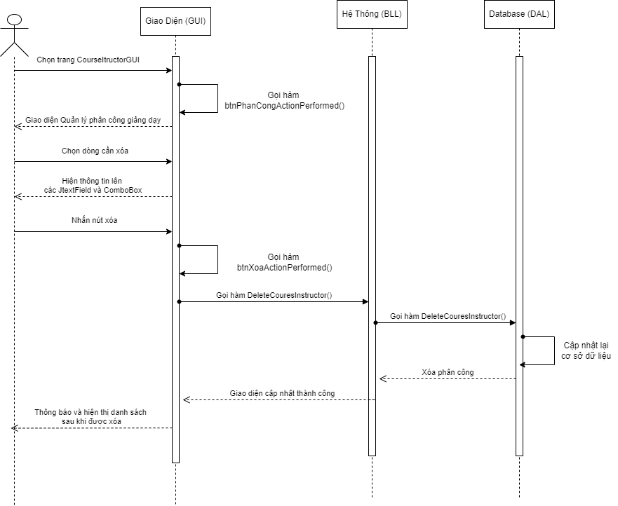

* **Màn hình giao diện**

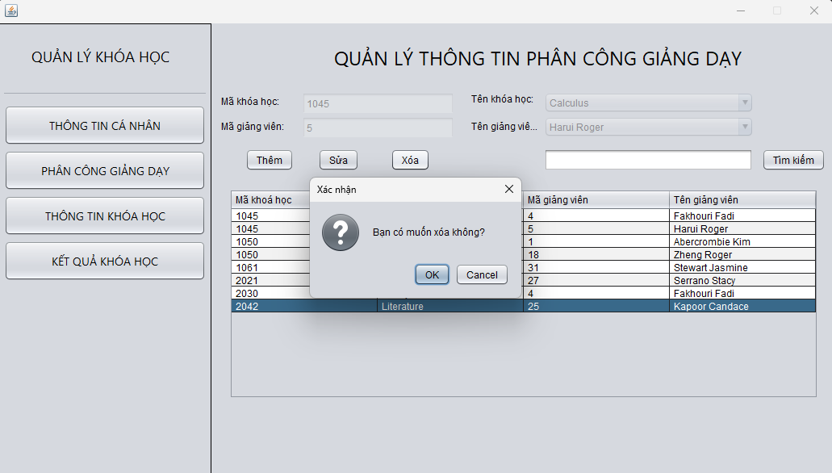

* **Code 3 class: DAL, BLL, GUI**

**DAL: CourseIntructorDAL.java**

public int deleteCourseInstructor(int CourseID, int PersonID) throws SQLException {

        String query = "DELETE FROM CourseInstructor WHERE CourseID = ? And PersonID = ?";

        PreparedStatement p = c.prepareStatement(query);

        p.setInt(1, CourseID);

        p.setInt(2, PersonID);

        int result = p.executeUpdate();

        return result;

 }

**BLL: CourseIntructorBLL.java**

public static int deleteCourseInstructor( int idcorse, int idperson) throws SQLException {

        return dal.deleteCourseInstructor(  idcorse, idperson);

}

**GUI: CourseIntructorGUI.java**

btnXoa.setText("Xóa");

        btnXoa.addActionListener(new java.awt.event.ActionListener() {

            public void actionPerformed(java.awt.event.ActionEvent evt) {

                btnXoaActionPerformed(evt);

            }

        });

        getContentPane().add(btnXoa, new org.netbeans.lib.awtextra.AbsoluteConstraints(220, 180, -1, -1));

private void btnXoaActionPerformed(java.awt.event.ActionEvent evt) {//GEN-FIRST:event_btnXoaActionPerformed

        int row = (int) ((JTable) this.tableCourseIns).getSelectedRow();

        if (row < 0) {

            JOptionPane.showMessageDialog(null, "Vui lòng chọn khóa học muốn xóa");

        } else {

            int result = JOptionPane.showConfirmDialog(null, "Bạn có muốn xóa không?", "Xác nhận", JOptionPane.OK_CANCEL_OPTION);

            if (result == JOptionPane.OK_OPTION) {

                try {

                    if (CourseInstructorBLL.deleteCourseInstructor(Integer.parseInt(maKH.getText()),Integer.parseInt(maGV.getText())) != 0 )  {

                        JOptionPane.showMessageDialog(null, "Xóa thành công!");

                        model = addArrayListToTable(cIBLL.loadDSCourseInstructor());

                        tableCourseIns.setModel(model);

                    } else {

                        JOptionPane.showMessageDialog(null, "Xóa thất bại!");

                    }

                } catch (Exception e) {

                    // TODO Auto-generated catch block

                    e.printStackTrace();

                }

            }

        }

 }

# **CHỨC NĂNG 3: QUẢN LÝ KẾT QUẢ KHÓA HỌC (STUDENTGRADE)**

## **3.1 Xử lý 1: hiển thị danh sách**

* **Sơ đồ tuần tự**

* **Màn hình giao diện**

* **Code 3 class: DAL, BLL, GUI**

## **3.2 Xử lý 2: hiển thị chi tiết 1 record (dòng)**

* **Sơ đồ tuần tự**

* **Màn hình giao diện**

* **Code 3 class: DAL, BLL, GUI**

## **3.3 Xử lý 3: thêm mới thông tin**

* **Sơ đồ tuần tự**

* **Màn hình giao diện**

* **Code 3 class: DAL, BLL, GUI**

## **3.4 Xử lý 4: sửa/ cập nhật thông tin**

* **Sơ đồ tuần tự**

* **Màn hình giao diện**

* **Code 3 class: DAL, BLL, GUI**

## **3.5 Xử lý 5: tìm kiếm**

* **Sơ đồ tuần tự**

* **Màn hình giao diện**

* **Code 3 class: DAL, BLL, GUI**

## **3.6 Xử lý 6: xóa record**

* **Sơ đồ tuần tự**

* **Màn hình giao diện**

* **Code 3 class: DAL, BLL, GUI**